Branding Guide

The purpose of this document is to provide guidelines on how to use the Common Ground Games brand assets, which include:

* The Common Ground Games logo in several iterations including one line, stacked, round, and textless variations
* Specific colors and combinations thereof
* Specific fonts we use in our advertising materials

Usage requirements

Thank you for your interest in supporting Common Ground Games. We created the Common Ground Games Brand Guidelines to manage and protect the value of the brand. By using any of the Common Ground Games brand assets, you expressly consent to be bound by these guidelines.

If you have an existing agreement with Common Ground Games, check that first to determine if your desired use of our brand assets is covered. If there is any conflict between these guidelines and the terms of your agreement, then the terms of your agreement will govern, and you should follow those.

If no agreement exists or if the proposed use doesn’t fall within the scope of your existing agreement, check if the use falls within the Common Ground Games Branding Guidelines.

Finally, if the use is not covered in any of the above or you are not sure, you may directly request clarification from Common Ground Games.

Logo Usage

**General usage**

It is important that the appearance of the logo remains consistent. The logo should not be misinterpreted, modified, or added to. No attempt should be made to alter the logo in any way. Its orientation, color and composition should remain as indicated in this document — there are no exceptions.

Minimum size: Establishing a minimum size ensures that the impact and legibility of the logo is not compromised in application. The Common Ground Games textless logo should never be smaller than 30px in digital or 8mm in print. The round logo with text should never be smaller than 50px in digital or 13.5mm in print. The stacked logo should never be smaller than 70px or 20mm in print. The horizontal one line logo should never be smaller than 113px or 30mm in print.

Exclusion zone: Ensure the Common Ground Games logo and text stands out from the surrounding text or background and is legible. Leave a space of half the height of the icon around the icon and/or wordmark when placing assets.

Logo misuse: Altering the Common Ground Games icon and text in any way is prohibited. Do not apply any gradient, rotate, change the color or tone, distort or warp, use the words without the icon, outline or create a keyline, or change the typeface, nor recreate or manipulate the wordmark and the icon.

If, when using the Common Ground Games brand assets, you include a trademark credit to give notice of your own trademarks or other third-party trademarks, we ask that you add the following wording: *“All other trademarks are the property of their respective owners.”*

Horizontal One Line

Stacked

Round w/ Text

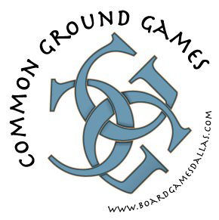

Round w/o Text



Black w/ text

Black w/o text

Colors

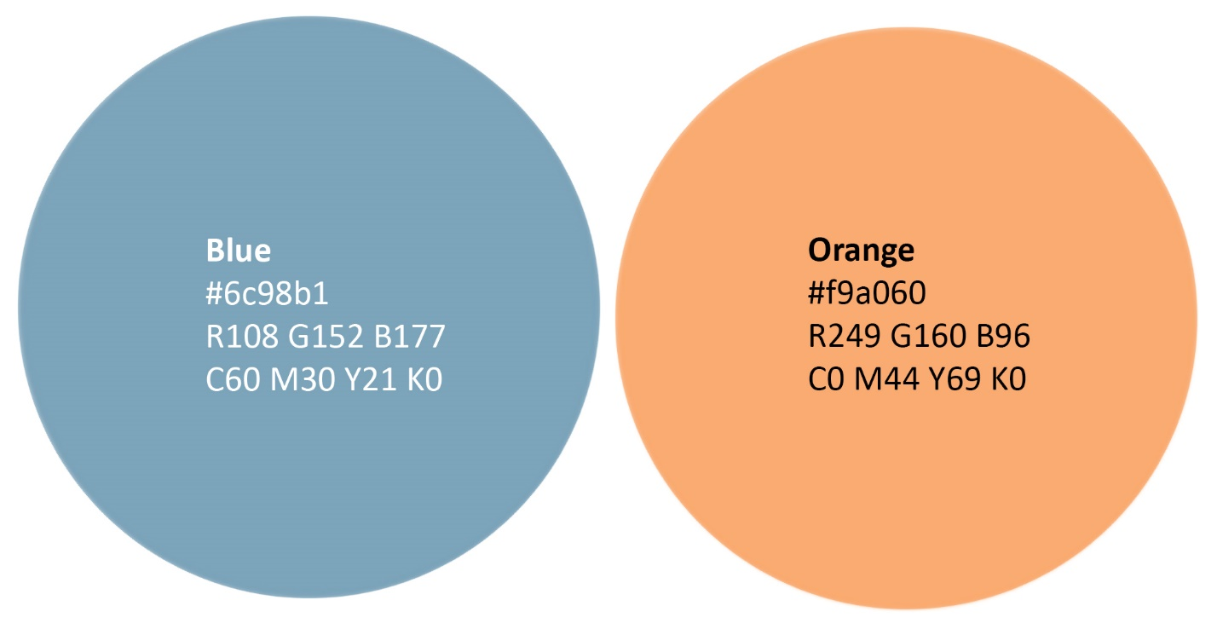

**Rules with colors**

Only the two above colors, black (#000000), and white (#FFFFFF) are acceptable colors for our branding. The Black w/ text and black w/o text logos should be used only on light backgrounds and the white versions on dark backgrounds for legibility.

|  |  |
| --- | --- |
| 6c98b1  81c3ef | F9a060 |

Fonts

Alice: Serif font. Used for print.

Primer Print: Sans-serif font. Used for digital and screen ads.

Prohibited uses

You must not incorporate any of the Common Ground Games brand assets, or variations of them, into your own product features, product names, service names, trademarks, logos, company names, domain names, or social media accounts unless otherwise permitted by the Common Ground Games Branding Guidelines.

You must not adopt marks, logos, or any other features that are confusingly similar to the Common Ground Games brand assets.

You must not copy or imitate the Common Ground Games trade dress, “look and feel”, or other identifiable and unique visual elements of the Common Ground Games brand assets including (but not limited to) the color combinations, graphics, imagery, presence icons, typefaces, or stylization used by Common Ground Games (or anything similar thereto).

You must not use the Common Ground Games brand assets in relation to products or services or on websites that may be considered sexually explicit, vulgar, profane, or offensive; obscene, defamatory, libelous, slanderous or otherwise unlawful; or religiously or racially offensive or otherwise promoting hate towards individuals or groups; or that violates any applicable laws or is otherwise objectionable to Common Ground Games, as determined by Common Ground Games in its sole discretion.

Make sure that any references to Common Ground Games are truthful, accurate, fair, and not misleading or in any way objectionable (as determined by Common Ground Games).

Thank You!

If you are having trouble with anything in this guide, you are missing brand elements from the brand package, or you are unsure if your communication best represents the Common Ground Games brand, please contact us at kim@boardgamesdallas.com